Casio Decision Mathematics Suite

# Analysis

## Problem Identification

Myself and my friends in our Further Mathematics class have encountered a problem with the Decision Mathematics modules. It is difficult to check if the answers we have given to questions are correct as the questions are complicated and the algorithms in use have multiple steps involved. It is easy to make a mistake while going through the steps of these algorithms, and it causes some confusion as to what the correct answer is. This is where it would be useful to have applications available to us in the lesson that can solve these problems for us. Most of us in the class have available to us a Casio FX-CG50 graphical calculator, which can have graphical programs written for it using the SDK.

The project aim is to create a suite of applications to solve all the problems available in the Edexcel Further Mathematics Decision module. These applications can be installed onto the Casio calculators and used as any other program on the calculator would be.

## Stakeholders

The stakeholders in this project would be myself and my classmates. Each of us would be capable of checking, testing and evaluating the individual applications and I would be able to frequently get new feedback from them.

Every one of us has a use for it as an academic tool – it allows us to write our own questions for revision and also mark them ourselves.

## Research

### Simplex

It is possible to solve simplex problems on the Casio FX-CG50 manually, using a matrix and matrix row operations. However, this is not an automated solution as wanted, and so is not exactly suited to the stakeholder’s requirements.

However, it would be useful to be able to enter a simplex tableau manually rather than have it automatically generated at all times, so this is definitely something I can take away as an idea.

### Transportation Problems

Transportation problems are a special case of linear programming problems, which makes them solvable by the simplex method, but it is generally more computationally efficient to solve them by different means.

I have been unable to find an implementation of the Stepping Stone algorithm (the method used to solve these problems) for Casio calculators. Additionally, it is not possible to use any of the features already available on the calculator to solve them manually.

Thusly the only available examples are online solvers such as this one:

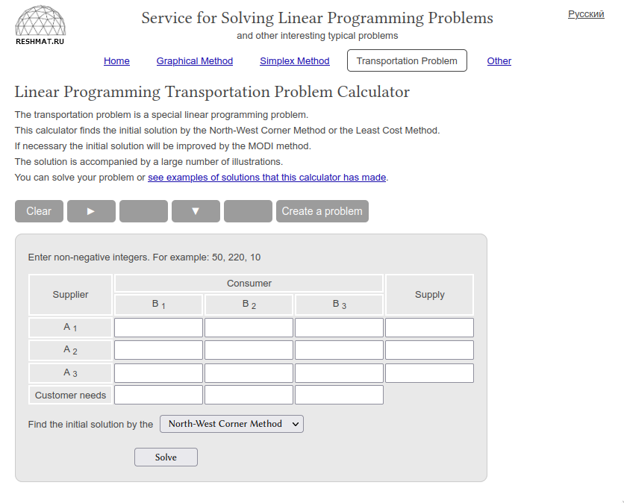(taken from <http://reshmat.ru/transportation_problem_lp.html>)

I will use a similar design for the program on the calculators – this is how the tables are laid out in the questions too, so it will be very easy to transfer the information to the calculator from the questions.

### Research Conclusions

Throughout the whole of my research I did not find any examples of a whole suite of applications like the one I am suggesting. I will be taking inspiration from the tools I found. However, the table layouts used in the tools are already what is standard and what is taught in the book, so not much new information can be garnered from these tools.

### Talking with Stakeholders

I sent my stakeholders, Toby, Jess and Guy the following message:

“The core idea of the project is to provide us with applications to use on our calculators to solve a variety fo the Decision problems, i.e. Transportation Problems and Linear Programming Problems. For these problems you’d be able to enter all the information in matrix forma like it’s given to you, and it would generate a solution for you, optionally showing the steps taken to attain the solution.”

Toby told me he was happy with the idea currently, and wanted to ensure that:

* There was “**outputs at all stages and highlighted changes in/ a different colour**”,
* And a **“usable ui”**

I asked for more detail about what a “usable ui” is:

It must be “obvious as to where numbers need to go, how to put them there and stuff”

Jess said:

“could you make it so that you could enter the same problem and see all the methods of getting the optimal solution? Also could you make it so that you could start at any stage of the problem? ”

## Essential Features

The desired solution will be a suite of applications, including an application to solve Transportation Problems, and Linear Programming problems. The users will be able to input the problem information, and the solution will be automatically generated, with the steps to attain such a solution shown if required. As my stakeholders identified, the user should be able to have the program highlight the changes as the solution progresses, so that they can see how the application is solving the problem. I also need to ensure that the UI is not confusing, that way the user can solve their problem easily. Finally, the application should be able to identify points where there are more than one choice, and show this to the user, as this can also show the user why a particular option may be better.

## Limitations

The limitations of my solution will stem largely from the hardware they are running on. The Casio FX-CG50 has only 61 kB of RAM available, and so the calculator would be unable to solve large problems, such as those that would be encountered in industry. This, however, will not come up to be an issue, as the solution developed for the calculators would not be used in an industry circumstance. The second limitation would be the way that data is entered into the solvers. Because the screen of the calculator is relatively small, it can only display a small amount of information on it at any one time. This small screen is less suited to entering larger amounts of data for larger problems. Thankfully, as this solution is only intended for use by students studying Further Mathematics Decision, the problems entered into the calculator would be restricted in their size.

## Requirements

### Hardware Requirements

A Casio FX-CG50 calculator, or similar calculator from the same line, will be required to run the applications, as well as the appropriate cables to install the software on the calculator. The cables usually come provided with the calculator. Additionally, a computer will be required to download the applications to get them onto the calculator, or use a calculator that already has the software installed and a link cable. It is preferable to install them from a computer as it is much faster than using the link cable between two calculators.

### Software Requirements

There are no additional software requirements, the calculators come with everything required to run the applications. It is recommeded, for testing or evaluation of the software, that anyone not in possesion of a Casio Graphics Calculator installs the Casio Calculator emulator: <https://education.casio.co.uk/download-emulator-cg>

## Success Criteria

|  |  |  |
| --- | --- | --- |
| Criteria | Evidence | Justification |
| Application to solve LP problems (Simplex Solver) | Picture of application installed on a calculator, pictures showing the application working | This is one half of the problem I am solving with this project. It is an essential part of the suite. |
| Application to solve Transportation Problems | Picture of application installed on a caluclator, pictures showing the application working | This is the other half of the problem I am solving with this project. It is an essential part of the suite. |
| Changes highlighted in solution steps | Picture of step before and step after, showing the changes that have been highlighted | Jess requested this feature. This would help the user to see how the algorithm is solving the problem. |
| Intuitive user-interface | Feedback from stakeholders affirming that the user-interface is intuitive | Toby asked me to ensure this was done. Making sure that it is not difficult to use the interface will make it much easier to solve a problem using my applications. |

# Design

## Common Matrix Design

Many of the applications will share a common matrix input screen, and so this can be developed as a modular solution and applied to each of the applications through importing an external utilities file.

## Separated Applications

It was considered to produce a single application that performs every different task required by the stakeholders, but I have decided against it, favouring a separated application suite. This will allow users to install whichever application(s) they require, rather than needing to fill the calculator’s limited storage space with an application they will not utilize fully.

## Overall Structure

To start with, only three applications will be developed; this is for multiple reasons. The primary reason being time constraint. I do not wish to be over-ambitious with the number of applications that can be developed in the time given, so I am restricting myself to three, before I can expand to possibly others. The second reason is for future planning: by developing only these three applications to start with, I can focus on the tools required to produce the programs effectively. This way I will be better able to consider the best way to develop more applications in the future, as well as will have more of my own tools/workflows available to me, having developed a few already.

The programs will be:

* Simplex Solver
* Transportation Problem Solver

These applications will share a common matrix design, which will accelerate application development to begin with.

### Simplex Solver

Upon opening the application, the user will immediately be asked how many variables the problem they are solving uses. After inputing their answer (which will likely be capped, an exact cap can be worked out later in development once the space complexity of the solution is attained). Then the user will then be asked if they are maximizing or minimizing the objective function. Once they have answered the previous, will be whether the problem uses >= constraints. If the problem does not, then the user will be asked to fill in their tableau at a matrix input screen. Else, the user will be asked if they would like to use Two Stage Simplex or Big M Method to solve the problem. The difference between these two methods will be detailed later in the section.

The Simplex algorithm is as follows (from Edexcel AS and A level Further Mathematics – Decision Mathematics 1):

1) Look along the objective row for the most negative entry: this indicates the **pivot column**.

2) Calculate the θ values, for each of the constraint rows, where θ = (the term in the value column) ÷ (the term in the pivot column)

3) Select the row with the smallest, positive θ value to become the pivot row.

4) The element in the pivow row and pivot column is the pivot.

5) Divide the row found in step 3 by the pivot, and change the basic variable at the start of the row to the variable at the top of the pivot column. This is now the pivot row.

6) Use the pivot row to eliminate the pivot’s variable from the other rows. This means that the pivot column now contains one 1 and zeros.

7) Repeat steps 3 to 6 until there are no more negative numbers in the objective row.

8) The tableau is now optimal, and the non-zero values can be read off using the basic variable column and value column

If the user wanted to minimize the objective function, rather than maximize, there is no difference in the algorithm itself. Instead, define a new objective function that is the negative of the original objective function. After the new objective function has been maximized, write the solution as the negative of this value, which will minimize the original objective function.

Two Stage Simplex method

The Two Stage Simplex method is one method used to solve linear programming problems containing constraints in the form a1x1 + a2x2 + … + anxn ≥ K

It is detailed as followed:

1) Use slack, surplus, and artificial variables, as necessary, to write all the contraints as equations.

2) Define a new objective function to minimize the sum of all the artificial variables.

3) Use the simplex methodto solve this problem

4) If the minimum sum of the artificial values is 0 then the solution found is a basic feasible solution of the original problem, which is then the starting point for the second stage. Use the simplex method again to solve this problem.

5) If the minimum sum of the artificial variables is not 0 then the original problem has no feasible solution.

The Big-M method

The Big-M method uses a conceptual number – M, which is arbitrarily large, to modifiy the objective function to also contain the artificial variables. By subtracting M x (sum of artificial variables) from the objective function, it becomes necessary for the algorithm to elminiate all artificial variables to optimize the tableau. The algorithm itself is the same as the simplex method, only using M for some values.

Once the user has decided what method they want to use to solve the problem, they will be taken to a matrix input screen, where they can fill in their tableau. Once the user has filled the tableau, they can press a function button on the calculator to run the algorithm. There will be two options, one to run through step-by-step, showing changes each time, and another to run all the way through and only show the end result.

### Transportation Problem Solver

When the user opens the application they will first be asked the number of supply and demand points in their solution. After filling both answers, the user may continue to fill in the cost matrix. They will be taken to a matrix input screen with dimensions corresponding to how many supply and demand points there are.

Once the user has input all cell costs, they can select one of two buttons – one to solve, showing each step, and another to run all the way through and only show the solution.

Once a button is selected, it must first be checked that the solution is **balanced**. This means that both the sums of supply and demand are equal. If they are not then a **dummy point** will need to be added to the matrix. If the demand is less than the supply, a **dummy demand point** will be added, equal to the difference between the supply and demand, making supply and demand now equal. Conversely, if supply is less than demand, then a **dummy supply point** is added, again with value equal to the difference. The cost of every cell for a demand point is 0.

Once any disagreements in supply and demand have been rectified, the full algorithm can run its course. In fact, there are multiple different algorithms/methods used in the process of solving a transportation problem, and each of them is named below, in order.

* North-West Corner method
* Finding shadow costs
* Finding improvement indices
* Stepping-Stone method

North-West Corner method

The North-West Corner method is used to find an initial solution to the problem. It generates a transport matrix that satisfies the conditions, but does not generate an optimal solution. It goes as follows:

1. Begin with the top left-hand corner. Allocate the maximum available quantity to meet the demand at this destination (whilst not exceeding the stock at this source).
2. As each stock is emptied, move one square down and allocate as many units as possilbe from the next source until the demand of the destination is met. As each demand is met, move the square to the right and again allocate as many units as possible.
3. When all the stock is assigned, and all the demands are met, stop.

Finding shadow costs

Shadow costs describe the “cost” of transporting a unit to/from a supply/demand point, agnostic of destination/source. They are required to find **improvement indices**. They are calculated as follows:

1. Start with the north-west corner, and set the cost linked with its source to zero.
2. Move along the row to any other non-empty squares. Set the cost linked with these destinations equal to the total transportation cost for that route (since the source cost for the first row is 0)
3. When all possible destination costs for that row have been established, go to the start of the next row.
4. Move along this row to any non-empty squares and use the destination costs found earlier, to establish the source cost for the row. Once that has been done, find any further unknown destination costs.
5. Repeat steps 3 and 4 until all source and destination costs have been found.

Finding improvement indices

Improvement indices show what cells not currently being used to transport stock are the cheapest. By identifying which cells are least costly, they can be introduced into the solution, eliminating those which have higher cost. Finding improvement indices is much simpler, and does not require an algorithm as such, rather a per-cell calculation:

Improvement IndexPQ = CostPQ – Source CostP – Destination CostQ

The cell with the most negative improvement index becomes the **entering cell** in the stepping-stone method. **If all improvement indices are zero or positive, the solution is optimal.**

Stepping-Stone method

The stepping-stone method is the “optimize away” step. It introduces the entering-cell into the solution, and in doing so reduces the use of other, more expensive, cells. It is done like so:

1. Create the cycle of adjustments. The two basic rules are:
   1. Within any row and any column there can only be one increasing cell and one decreasing cell.
   2. Apart from the entering cell, adjustments are only made to non-empty cells.
2. Once the cycle of adjustments has been found, you transfer the maximum number of units through this cycle. This will be equal to the smallest number in the decreasing cells.
3. You then adjust the solution to incorporate this improvement.

Doing an iteration of the stepping stone method does not guarantee an optimal solution, only an improvement (unless the solution is already optimal). The whole process may need to be repeated many times to generate an optimal solution.

* 1. 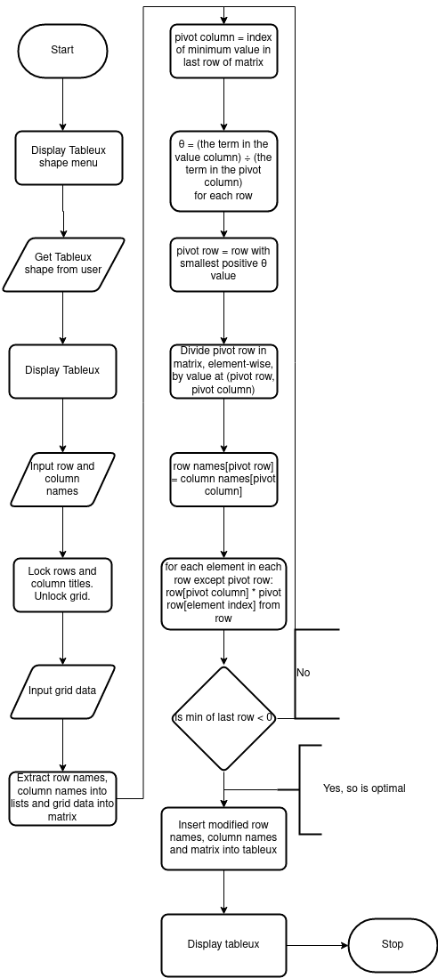

## Required Data Structures and Classes

It will be necessary to develop a table/matrix class that can perform row and column operations, as well as hold both tuples and numbers in its cells. I plan to represent numbers such as (1 + M) or (3 – 5M) as tuples like so: (1, M()) and (3, M(-5)).

It will also be necessary to create an M data type, which will need a value attribute, for representations greater than one M. In all cases, when compared with a normal number, M will be larger. If it is to be compared with another M, it will be necessary to look at the values of both to determine which is larger.

It will also be useful to have a generic matrix/table display class that can be used to display an n×m matrix. As many of the applications will use this kind of input, this is necessary to avoid constantly rewriting the same thing. The display class will take a matrix class as an input, and use it as the data to be displayed.

## Usability Features

All applications will have the capability to take the user a step back by pressing the Exit key on the calculator. This will prevent the user having their time wasted if they accidentally enter wrong data, as they will not have to go through the whole process if they enter wrong data accidentally, and can instead just go back.

## Test Data

It will be very important to consider how much memory and CPU the applications will use. For this reason I will be collecting detailed profiling information for every application. When it comes to testing the individual applications, I will be using valid and extreme valid, as the way I plan on writing the applications they will not accept invalid data. This will also need testing in some way, so I will attempt to enter invalid data at every stage. For valid testing I will be using questions from the textbooks provided, as these come with solutions, and for extreme valid I will be creating problems that have no solution.

# Development of the Coded Solution

## Stage 1: Library Development

The first part of development should be to write the classes and data types needed for the rest of development, and to review them before writing them into the full solution. This way it can be ensured that they are as efficient as possible. I will begin by writing the matrix class. I am going to prototype everything in Python first, as development in Python is quicker to iterate. Once I consider the prototype working, I will then translate all the code I have to C.

First, ensuring that any data passed into the class is validated. Running this code, which passes too much data to the class, correctly raises an AttributeError:

**class** **Matrix**:

**def** __init__(self, dims: (int, int), data: [float]):

**if** len(data)/dims[0] != dims[1]:

**raise** **AttributeError**(

f"Dimensions **{**dims**}** do not match data len (**{**len(data)**}**)")

self.dims = dims

self.data = data

A = Matrix((2, 2), [1, 2, 3, 4, 5])

Traceback (most recent call last):

File "/home/leet/Documents/GitHub/NEA-Project/src/python-prototyping/lib.py", line 10, **in** <module>

A = Matrix((2, 2), [1, 0, 1, 0, 1])

File "/home/leet/Documents/GitHub/NEA-Project/src/python-prototyping/lib.py", line 4, **in** __init__

**raise** **AttributeError**(

**AttributeError**: Dimensions (2, 2) do **not** match data len (5)

Next, I implement a __getitem__() function so that our matrices can be indexed. Indexing a matrix will return a row list, which can be indexed by default.

*# …*

*# ...*

**def** __getitem__(self, index: int):

start_index = self.dims[1]*index

end_index = self.dims[1]*index+self.dims[0]

**return** self.data[start_index:end_index]

*# This represents a matrix like such:*

*# | 1 3 |*

*# | 2 4 |*

A = Matrix((2, 2), [1, 2, 3, 4])

*# Should print [1, 2]*

print(A[0], A[1])

This code outputs:

[1, 2] [3, 4]

This is correct, and testing it with a larger, non-square matrix (dimensions 5x3):

A = Matrix((5, 3), [1, 2, 3, 4, 5, 6, 7, 8, 9, 10, 11, 12, 13, 14, 15])

*# Should print [1, 2, 3] [13, 14, 15]*

print(A[0], A[4])

Outputs:

[1, 2, 3, 4, 5] [13, 14, 15]

This is wrong, and I believe that this is due to the way I find the end index. Changing the code for finding the end index to:

end_index = self.dims[1]*(index + 1)

works exactly as intended, and the code now prints what it should:

[1, 2, 3] [13, 14, 15]

Next, I would like to be able to add or subtract numbers from rows and columns. There is no need to implement two functions for adding and subtracting, as I can simply add a negative number. This will reduce code size, which is important in these applications. In order to be able to change the

values in rows and columns, I need a __setitem__ function.

*# Sets the column at `index` to `new_col`*

**def** __setitem__(self, index: int, new_col: [float]):

*# The value by which all changes are shifted*

shift = index*self.dims[1]

**for** col_index, item **in** enumerate(new_col):

self.data[shift+col_index] = new_col[col_index]

Now, trying to change the first column in a 2x2 matrix:

*# This represents a matrix like such:*

*# | 1 3 |*

*# | 2 4 |*

A = Matrix((2, 2), [1, 2, 3, 4])

A[0] = [5, 6]

*# Should print [5, 6] [3, 4]*

print(A[0], A[1])

Prints:

[5, 6] [3, 4]

I forgot to implement any kind of validation, so have now implemented it. The __setitem__ function now looks like this:

*# Sets the column at `index` to `new_col`*

**def** __setitem__(self, index: int, new_col: [float]):

*# If new_col is wrong length, raise*

**if** len(new_col) != self.dims[1]:

**raise** **ValueError**(

f"Error assigning new value to matrix column. New value has length**\**

**{**len(new_col)**}** but matrix has height **{**self.dims[1]**}**")

*# The value by which all changes are shifted*

shift = index*self.dims[1]

*# Iterate through the new column, and change*

*# appropriate cells to new values*

**for** col_index, item **in** enumerate(new_col):

self.data[shift+col_index] = new_col[col_index]

If we try to set an inappropriate length column to the matrix:

A = Matrix((2, 2), [1, 2, 3, 4])

A[0] = [5, 6, 7]

The program correctly errors:

Traceback (most recent call last):

File "/home/leet/Documents/GitHub/NEA-Project/src/python-prototyping/lib.py", line 41, **in** <module>

A[0] = [5, 6, 7]

File "/home/leet/Documents/GitHub/NEA-Project/src/python-prototyping/lib.py", line 21, **in** __setitem__

**raise** **ValueError**(

**ValueError**: Error assigning new value to matrix column. New value has length 3 but matrix has height 2

I also need to be able to change individual cells this way, and reflecting on this, I have decided to change both get and set functions accordingly. The new functions look like this:

*# Returns the value at index `index`*

**def** __getitem__(self, index: (int, int)):

item_index = self.dims[1]*index[0] + index[1]

**return** self.data[item_index]

*# Sets the value at `index` to `val`*

**def** __setitem__(self, index: (int, int), val: float):

*# If val is wrong type, error*

**if** **not** isinstance(val, numbers.Number):

**raise** **ValueError**(

f"Error assigning new value to matrix cell. New value has type**\**

**{**type(val)**}**, which is not a number type.")

item_index = self.dims[1]*index[0] + index[1]

self.data[item_index] = val

I have needed to import the “numbers” module, which is part of the Python standard library. This is needed to validate that the new value is a number type. The following code:

Outputs, correctly:

2

7

Now I can continue to write my rowadd and coladd functions.

*# Add `num` to every cell in row `row_index`*

def rowadd(self, row_index: int, num: float):

**for** i **in** **range**(self.dims[0]):

self.**data**[self.dims[1]*i + row_index] += num

def coladd(self, col_index: int, num: float):

**for** j **in** **range**(self.dims[1]):

self.**data**[self.dims[1]*col_index + j] += num

Testing with the following code:

A = Matrix((2, 2), [1, 2, 3, 4])

*# Should print [1, 3]*

print([A[0, 0], A[1, 0]])

*# Changes 1 to 11 and 3 to 13*

A.rowadd(0, 10)

*# Should print [11, 13]*

print([A[0, 0], A[1, 0]])

*# Should print [13, 4]*

print([A[1, 0], A[1, 1]])

*# Changes 13 to 23 and 4 to 14*

A.coladd(1, 10)

*# Should print [23, 14]*

print([A[1, 0], A[1, 1]])

Outputs, correctly:

[1, 3]

[11, 13]

[13, 4]

[23, 14]

Now that I can add to columns and rows, I would also like to be able to multiply across them. Implementing very similar functions is very easy.

*# Multiply every cell in row `row_index` by `num`*

**def** rowmul(self, row_index: int, num: float):

**for** i **in** range(self.dims[0]):

self.data[self.dims[1]*i + row_index] *= num

*# Multiply every cell in column `col_index` by `num`*

**def** colmul(self, col_index: int, num: float):

**for** j **in** range(self.dims[1]):

self.data[self.dims[1]*col_index + j] *= num

Tested with the following code:

A = Matrix((2, 2), [1, 2, 3, 4])

*# Should print [1, 3]*

print([A[0, 0], A[1, 0]])

*# Changes 1 to 10 and 3 to 30*

A.rowmul(0, 10)

*# Should print [10, 30]*

print([A[0, 0], A[1, 0]])

*# Should print [30, 4]*

print([A[1, 0], A[1, 1]])

*# Changes 30 to 15 and 4 to 2*

A.colmul(1, 0.5)

*# Should print [15, 2]*

print([A[1, 0], A[1, 1]])

Outputs, correctly:

[1, 3]

[10, 30]

[30, 4]

[15.0, 2.0]

At this point I consider the Matrix data type fully developed as I need it currently. I may find myself adding to it later in development, but this is all the functionality I need for the Simplex Solver. The final code for the entire class is such:

**class** **Matrix**:

**def** __init__(self, dims: (int, int), data: [float]):

*# If the amount of data provided does*

*# not fit within the dimensions, error*

**if** len(data)/dims[0] != dims[1]:

**raise** **ValueError**(

f"Dimensions **{**dims**}** do not match data len (**{**len(data)**}**)")

self.dims = dims

self.data = data

*# Returns the value at index `index`*

**def** __getitem__(self, index: (int, int)):

item_index = self.dims[1]*index[0] + index[1]

**return** self.data[item_index]

*# Sets the value at `index` to `val`*

**def** __setitem__(self, index: (int, int), val: float):

*# If val is wrong type, error*

**if** **not** isinstance(val, numbers.Number):

**raise** **ValueError**(

f"Error assigning new value to matrix cell. New value has type**\**

**{**type(val)**}**, which is not a number type.")

item_index = self.dims[1]*index[0] + index[1]

self.data[item_index] = val

*# Add `num` to every cell in row `row_index`*

**def** rowadd(self, row_index: int, num: float):

**for** i **in** range(self.dims[0]):

self.data[self.dims[1]*i + row_index] += num

*# Add `num` to every cell in column `col_index`*

**def** coladd(self, col_index: int, num: float):

**for** j **in** range(self.dims[1]):

self.data[self.dims[1]*col_index + j] += num

*# Multiply every cell in row `row_index` by `num`*

**def** rowmul(self, row_index: int, num: float):

**for** i **in** range(self.dims[0]):

self.data[self.dims[1]*i + row_index] *= num

*# Multiply every cell in column `col_index` by `num`*

**def** colmul(self, col_index: int, num: float):

**for** j **in** range(self.dims[1]):

self.data[self.dims[1]*col_index + j] *= num

The next class I need is a way to represent Big M. I will write my own M class which will have a regular number value and an M value.

**class** **M**(numbers.Number):

*# M class is a number with two values.*

*# One regular number value, and another Big M value.*

**def** __init__(self, num_val, m_val):

self.num_val = num_val

self.m_val = m_val

**def** __repr__(self):

**if** self.m_val < 0:

**return** f"(**{**self.num_val**}** - **{**abs(self.m_val)**}**M)"

**return** f"(**{**self.num_val**}** + **{**self.m_val**}**M)"

I have defined the core of the class. I can now create an instance of M, which I can also print using its __repr__.

num = M(-1, 3)

*# Should print (-1 + 3M)*

print(num)

Outputs:

(-1 + 3M)

Now that I can instantiate and print an M class, I want to be able to perform comparisons with it.

**def** __gt__(self, other):

**if** isinstance(other, M):

**return** self.m_val > other.m_val

**return** **True**

**def** __lt__(self, other):

**if** isinstance(other, M):

**return** self.m_val < other.m_val

**return** **False**

**def** __gte__(self, other):

**if** isinstance(other, M):

**return** self.m_val >= other.m_val

**return** **True**

**def** __lte__(self, other):

**if** isinstance(other, M):

**return** self.m_val <= other.m_val

**return** **False**

**def** __eq__(self, other):

**if** isinstance(other, M):

**return** self.m_val == other.m_val **and** self.num_val == other.num_val

**return** **False**

This is the code I had originally written to perform comparisons with, although after some consideration I have realized it is faulty. When performing comparisons, for all of them except __eq__, I have neglected to consider the non M part. This leads to incorrect results:

num1 = M(10, 4)

num2 = M(0, 4)

*# Should print True*

print(num1 > num2)

Outputs:

**False**

I have corrected the code for comparisons, and the new code looks like this:

**def** __gt__(self, other):

**if** isinstance(other, M):

**return** (self.m_val > other.m_val) **or** (self.m_val == other.m_val **and**

self.num_val > other.num_val)

**return** **True**

**def** __lt__(self, other):

**if** isinstance(other, M):

**return** (self.m_val > other.m_val) **or** (self.m_val == other.m_val **and**

self.num_val > other.num_val)

**return** **False**

**def** __gte__(self, other):

**if** isinstance(other, M):

**return** (self.m_val >= other.m_val) **or** (self.m_val == other.m_val **and**

self.num_val >= other.num_val)

**return** **True**

**def** __lte__(self, other):

**if** isinstance(other, M):

**return** (self.m_val <= other.m_val) **or** (self.m_val == other.m_val **and**

self.num_val <= other.num_val)

**return** **False**

**def** __eq__(self, other):

**if** isinstance(other, M):

**return** self.m_val == other.m_val **and** self.num_val == other.num_val

**return** **False**

Using the same test code for comparisons, the output is now, correctly:

**True**

Now that I have working code for comparisons, I would like to be able to perform arithmetic operations on M types. This will make it easier to add, subtract multiply etc.

**def** __add__(self, other):

**if** isinstance(other, M):

self.m_val += other.m_val

self.num_val += other.num_val

**return** self

self.num_val += other

**return** self

**def** __sub__(self, other):

**if** isinstance(other, M):

self.m_val -= other.m_val

self.num_val -= other.num_val

**return** self

self.num_val -= other

**return** self

**def** __mul__(self, other):

**if** isinstance(other, M):

self.m_val *= other.m_val

self.num_val *= other.num_val

**return** self

self.num_val *= other

**return** self

**def** __div__(self, other):

**if** isinstance(other, M):

self.m_val *= other.m_val

self.num_val *= other.num_val

**return** self

self.num_val *= other

**return** self

Now that I’ve written the arithmetic code, testing it:

num1 = M(10, 4)

num2 = M(0, 4)

*# Should print (10, 8M)*

print(num1 + num2)

Output:

(10 + 8M)

### Review

Reviewing the Matrix class, I have noticed that the way the index is calculated is in fact wrong. I also wanted to be able to use negative indices to access the end of rows and columns. The new modified code below generates the correct index from the row and column numbers:

index_0, index_1 = index

**if** index_0 < 0:

index_0 = self.dims[0]+index_0

**if** index_1 < 0:

index_1 = self.dims[1]+index_1

item_index = index_0 + self.dims[0]*index_1

I have also implemented a __repr__ function so that I can print out a whole matrix, which makes developing and debugging easier. In addition I have modified all matrix functions to use the matrix indexing rather than directly modifying self.data.

**def** __repr__(self):

output = ""

**for** j **in** range(self.dims[1]):

**for** i **in** range(self.dims[0]):

output += str(self[i, j])

output += ' '

output += "**\n**"

**return** output

Another change I would like to make is to the matrix class. I would like to be able to select individual rows and columns from the matrix and to be able to add rows and columns together. I have implemented this below.

**def** row(self, row_index):

**return** MatrixRow([self[i, row_index] **for** i **in** range(self.dims[0])])

**def** column(self, col_index):

**return** MatrixCol([self[col_index, j] **for** j **in** range(self.dims[1])])

*# Add `num` to every cell in row `row_index`*

**def** rowadd(self, row_index: int, other: float):

**for** i **in** range(self.dims[0]):

**if** isinstance(other, Number):

self[i, row_index] += other

**elif** isinstance(other, list):

self[i, row_index] += other[i]

**else**:

**raise** **ValueError**(f"Type of other is not number or list: **{**type(other)**}**")

*# Add `num` to every cell in column `col_index`*

**def** coladd(self, col_index: int, other: float):

**for** j **in** range(self.dims[1]):

**if** isinstance(other, Number):

self[col_index, j] += other

**elif** isinsance(other, list):

self[col_index, j] += other[j]

**else**:

**raise** **ValueError**(f"Type of other is not number or list: **{**type(other)**}**")

I have used custom MatrixRow and MatrixCol types to achieve this. They are defined as such.

**class** **MatrixRow**(list):

**def** __getitem__(self, key):

**return** super(MatrixRow, self).__getitem__(key)

**def** __setitem__(self, key):

**return** super(MatrixRow, self).__setitem__(key)

**def** __mul__(self, other):

**for** i **in** range(len(self)):

self[i] *= other

**class** **MatrixCol**(list):

**def** __getitem__(self, key):

**return** super(MatrixCol, self).__getitem__(key)

**def** __setitem__(self, key):

**return** super(MatrixCol, self).__setitem__(key)

**def** __mul__(self, other):

**for** i **in** range(len(self)):

self[i] *= other

## Stage 2: Simplex Solver

In a new file, I have begun writing the code for the simplex solver. The first step is to find the pivot column.

**def** pivot_column(matrix):

objective_row = [matrix[i, matrix.dims[1]-1] **for** i **in** range(matrix.dims[0])]

**return** objective_row.index(min(objective_row))

Testing this with the following code:

*# x y z r s t Value*

data = [-0.25, 0, -0.5, 1, 0, -0.75, 8, *# r*

2.5, 0, 2, 0, 1, -0.5, 92, *# s*

0.75, 1, 0.5, 0, 0, 0.25, 24, *# y*

3, 0, -6, 0, 0, 5, 480] *# P*

mat = Matrix((len(column_names), len(row_names)), data)

*# Should print 2*

print(pivot_column(mat))

Outputs:

2

Next, I need to find the pivot row and thereby the pivot cell.

**def** pivot_row(matrix, column):

thetas = []

indices = []

**for** j **in** range(matrix.dims[1]-1):

theta = matrix[-1, j] / matrix[column, j]

**if** theta >= 0:

thetas.append(theta)

indices.append(j)

index = indices[0]

theta = thetas[0]

**for** ind, thet **in** zip(indices, thetas):

**if** thet < theta:

theta = thet

index = ind

**return** index

Testing with this code:

*# x y z r s t Value Theta*

data = [-0.25, 0, -0.5, 1, 0, -0.75, 8, *# r -16*

2.5, 0, 2, 0, 1, -0.5, 92, *# s46*

0.75, 1, 0.5, 0, 0, 0.25, 24, *# y 48*

3, 0, -6, 0, 0, 5, 480] *# P*

mat = Matrix((len(column_names), len(row_names)), data)

column = pivot_column(mat)

row = pivot_row(mat, column)

pivot_cell = (column, row)

*# Should print (2, 1)*

print(pivot_cell)

Outputs:

(2, 1)

Next is step 5 and 6 of the algorithm. I need to divide the pivot row by the value in the pivot cell, and then subtract multiples of the pivot row from the other rows, such that the pivot column only contains one 1.

**def** simplex(matrix):

column = pivot_column(matrix)

row = pivot_row(matrix, column)

matrix.rowmul(row, 1/matrix[column, row])

**return** matrix

Testing this with the same data matrix:

mat = Matrix((len(column_names), len(row_names)), data)

*# Should show that (2, 1) has become 1*

print(simplex(mat))

Outputs:

-0.25 0 -0.5 1 0 -0.75 8

1.25 0.0 1.0 0.0 0.5 -0.25 46.0

0.75 1 0.5 0 0 0.25 24

3 0 -6 0 0 5 480

This is correct, but the output is extremely difficult to read without significant effort, so I have decided that I am going to rewrite the __repr__ for the matrix class to pad between each value, so that all values in the same column are lined up. The function now looks like this:

**def** __repr__(self):

output = ""

length = [0 **for** i **in** range(self.dims[0])]

**for** i **in** range(self.dims[0]):

**for** j **in** range(self.dims[1]):

**if** len(str(self[i, j])) > length[i]:

length[i] = len(str(self[i, j]))

**for** j **in** range(self.dims[1]):

**for** i **in** range(self.dims[0]):

output += f" **{**' '*(length[i]-len(str(self[i, j])))**}{**self[i, j]**}** "

output += "**\n**"

**return** output

And the output is much cleaner:

-0.25 0 -0.5 1 0 -0.75 8  
 1.25 0.0 1.0 0.0 0.5 -0.25 46.0  
 0.75 1 0.5 0 0 0.25 24  
 3 0 -6 0 0 5 480

The next step is to reduce the rest of the columns, such that the pivot column contains a single 1, in the pivot cell.

**def** simplex(matrix):

column = pivot_column(matrix)

row = pivot_row(matrix, column)

matrix.rowmul(row, 1/matrix[column, row])

**for** i **in** range(matrix.dims[1]):

**if** i == row:

**continue**

row_modifier = matrix.row(row)*(-matrix[column, i])

matrix.rowadd(i, row_modifier)

**return** matrix

Testing, now with a smaller matrix from the textbook:

*# x y r s Value*

data = [ 5, 7, 1, 0, 70, *# r*

10, 3, 0, 1, 60, *# s*

-3, -2, 0, 0, 0] *# P*

mat = Matrix((len(column_names), len(row_names)), data)

print(mat)

*# Should show that the 0th column has one 1 and the*

*# rest are zeros*

print(simplex(mat))

Outputs:

5 7 1 0 70

10 3 0 1 60

-3 -2 0 0 0

0.0 5.5 1.0 -0.5 40.0

1.0 0.30000000000000004 0.0 0.1 6.0

0.0 -1.0999999999999999 0.0 0.30000000000000004 18.0

While this output is correct: the zeroth column is how it should be, I have encountered an issue with floating point arithmetic. Floating point arithmetic is prone to inaccuracies, for example -1.0999999999999999 is meant to represent 1.1. This issue can be solved with part of Python's standard library, the "fractions" module. The fractions module allows you to represent any rational number as a fraction without losing precision. In order to implement the fractions module I will need to make some changes to my library.

I have modified the __init__ function for the Matrix class, it now converts all values to fractions during initialisation.

self.data = [Fraction(num) **for** num **in** data]

This now works without problem, and I have regained the accuracy I require.

5 7 1 0 70

10 3 0 1 60

-3 -2 0 0 0

0 11/2 1 -1/2 40

1 3/10 0 1/10 6

0 -11/10 0 3/10 18

Now that I can perform one iteration on the matrix, I want to be able to check if the solution is optimal. This is done by seeing if the most negative entry in the objective row is negative. If it is not, the solution is optimal.

**def** isoptimal(matrix, objective_row=-1):

**return** min(matrix.row(objective_row)) >= 0

The reasoning behind the objective_row parameter is that the objective row changes during the course of the Two Stage Simplex algorithm. I modified the simplex function so that it will run until the solution is optimal.

**def** simplex(matrix):

**while** **not** isoptimal(matrix):

column = pivot_column(matrix)

row = pivot_row(matrix, column)

matrix.rowmul(row, 1/matrix[column, row])

**for** i **in** range(matrix.dims[1]):

**if** i == row:

**continue**

row_modifier = matrix.row(row)*(-matrix[column, i])

matrix.rowadd(i, row_modifier)

**return** matrix

Testing, the function now returns the optimal solution that is written in the textbook.

# x y r s Value

data = [ 5, 7, 1, 0, 70, # r

10, 3, 0, 1, 60, # s

-3, -2, 0, 0, 0] # P

mat = Matrix((len(column_names), len(row_names)), data)

print(simplex(mat))

Outputs:

0 1 2/11 -1/11 80/11

1 0 -3/55 7/55 42/11

0 0 1/5 1/5 26

It is important that for the solution to be useful, we can see the row names and column names of the matrix. I am going to implement a DisplayMatrix class for this. This class will use the same __repr__, __getitem__ and __setitem__ as the Matrix class, but will not have any of the other functionality available. The important distinction is that the DisplayMatrix class takes a string as its values.

**class** **DisplayMatrix**():

**def** __init__(self, matrix, col_names, row_names):

self.dims = (matrix.dims[0]+1, matrix.dims[1]+1)

self.data = [" "]

self.data.extend(col_names)

**for** i **in** range(len(row_names)):

row = matrix.row(i)

row.insert(0, row_names[i])

self.data.extend(row)

**for** i **in** range(len(self.data)):

self.data[i] = str(self.data[i])

*# Returns the value at index `index`*

**def** __getitem__(self, index: (int, int)):

index_0, index_1 = index

**if** index_0 < 0:

index_0 = self.dims[0]+index_0

**if** index_1 < 0:

index_1 = self.dims[1]+index_1

item_index = index_0 + self.dims[0]*index_1

**if** item_index > self.dims[0]*self.dims[1]:

**raise** **IndexError**(f"Index [**{**index[0]**}**, **{**index[1]**}**] out of range")

**return** self.data[item_index]

*# Sets the value at `index` to `val`*

**def** __setitem__(self, index: (int, int), val: str):

index_0, index_1 = index

**if** index_0 < 0:

index_0 = self.dims[0]+index_0

**if** index_1 < 0:

index_1 = self.dims[1]+index_1

item_index = index_0 + self.dims[0]*index_1

**if** item_index > self.dims[0]*self.dims[1]:

**raise** **IndexError**(f"Index [**{**index[0]**}**, **{**index[1]**}**] out of range")

self.data[item_index] = val

**def** __repr__(self):

output = ""

length = [0 **for** i **in** range(self.dims[0])]

**for** i **in** range(self.dims[0]):

**for** j **in** range(self.dims[1]):

**if** len(str(self[i, j])) > length[i]:

length[i] = len(self[i, j])

**for** j **in** range(self.dims[1]):

**for** i **in** range(self.dims[0]):

output += f" **{**' '*(length[i]-len(self[i, j]))**}{**self[i, j]**}** "

output += "**\n**"

**return** output

Next, I have modified the simplex function so that it performs the necessary changes to the row names.

*# ...*

matrix.rowmul(row, 1/matrix[column, row])

row_names[row] = column_names[column]

*# ...*

Now I can output the matrix, including the row and column names.

column_names = ["x", "y", "r", "s", "Value"]

row_names = ["r", "s", "P"]

# x y r s Value

data = [ 5, 7, 1, 0, 70, # r

10, 3, 0, 1, 60, # s

-3, -2, 0, 0, 0] # P

mat = Matrix((len(column_names), len(row_names)), data)

mat, column_names, row_names = simplex(mat, column_names, row_names)

print(DisplayMatrix(mat, column_names, row_names))

Outputs:

x y r s Value

y 0 1 2/11 -1/11 80/11

x 1 0 -3/55 7/55 42/11

P 0 0 1/5 1/5 26

This now is much more useful. Now I can read the solution and say that the optimal solution, for 26 profit, requires 80/11 y and 42/11 x.

I want to implement Toby's requests now, specifically to be able to show the changes of each iteration.

I have updated the display matrix __init__ so that the pivot cell is indicated by being surrounded with *. In the final application this will be highlighting, but a more rudimentary approach here is better to just get it implemented.

**class** **DisplayMatrix**():

**def** __init__(self, matrix, col_names, row_names, changes=(-1, -1)):

*# ...*

*# ...*

**if** sum(changes) >= 0:

self[changes[0]+1, changes[1]+1] = f"\***{**self[changes[0]+1, changes[1]+1]**}**\*"

I've also updated the simplex function. It is now a generator, so it must be called as such.

**def** simplex(matrix, column_names, row_names, show_changes=**False**):

**while** **not** isoptimal(matrix):

column = pivot_column(matrix)

row = pivot_row(matrix, column)

matrix.rowmul(row, 1/matrix[column, row])

row_names[row] = column_names[column]

**for** i **in** range(matrix.dims[1]):

**if** i == row:

**continue**

row_modifier = matrix.row(row)*(-matrix[column, i])

matrix.rowadd(i, row_modifier)

**if** show_changes:

**yield** matrix, row_names, (column, row)

Running with slightly different code:

mat = Matrix((len(column_names), len(row_names)), data)

**for** mat, row_names, pivot_cell **in** simplex(mat,

column_names,

row_names,

show_changes=**True**):

print(DisplayMatrix(mat,

column_names,

row_names,

changes=pivot_cell)

)

Outputs:

x y r s Value

r 0 11/2 1 -1/2 40

x *1* 3/10 0 1/10 6

P 0 -11/10 0 3/10 18

x y r s Value

y 0 *1* 2/11 -1/11 80/11

x 1 0 -3/55 7/55 42/11

P 0 0 1/5 1/5 26

The next step is Two Stage Simplex. This is actually a fairly simplex addition. I do need to make some changes to the simplex function and the way I find the pivot column first, however. I need to ensure that the pivot column is not chosen from either of the objective rows in the Two Stage case, as the matrix for two stage contains two objective rows.

**def** pivot_row(matrix, column, two_stage=**False**):

thetas = []

indices = []

rows = [j **for** j **in** range(matrix.dims[1] - 1)]

**if** two_stage:

rows = [j **for** j **in** range(matrix.dims[1] - 2)]

**for** j **in** rows:

**if** matrix[column, j] == 0:

theta = inf

**else**:

theta = matrix[-1, j] / matrix[column, j]

**if** theta >= 0:

thetas.append(theta)

indices.append(j)

index = indices[0]

theta = thetas[0]

**for** ind, thet **in** zip(indices, thetas):

**if** thet < theta:

theta = thet

index = ind

**return** index

I have added an optional `two_stage` flag, which if enabled changes the rows checked to no longer include the extra objective row. Now I just need to add this flag to the simplex function, as other than that the algorithm is not affected.

**def** simplex(matrix,

column_names,

row_names,

objective_row=-1,

two_stage=**False**,

show_changes=**False**):

**while** **not** isoptimal(matrix, objective_row=objective_row):

column = pivot_column(matrix, objective_row=objective_row)

row = pivot_row(matrix, column, two_stage=two_stage)

matrix.rowmul(row, 1 / matrix[column, row])

row_names[row] = column_names[column]

**for** i **in** range(matrix.dims[1]):

**if** i == row:

**continue**

row_modifier = matrix.row(row) * (-matrix[column, i])

matrix.rowadd(i, row_modifier)

**if** show_changes:

**yield** matrix, row_names, (column, row)

**if** **not** show_changes:

**yield** matrix, row_names, (-1, -1)

Now that this is done, I can test it:

column_names = ["x", "y", "z", "s1", "s2", "s3", "a1", "a2", "Value"]

row_names = ["s1", "s2", "a1", "P", "I"]

*# x y z s1 s2 s3 a1 a2 Value*

data = [1, 1, 2, 1, 0, 0, 0, 0, 10, *# s1*

-3, 1, 0, -1, 0, 1, 0, 5, *# a1*

1, 0, 0, 0, -1, 0, 1, 8, *# a2*

-3, 2, -1, 0, 0, 0, 0, 0, 0, *# P*

-3, 2, -1, 0, 1, 1, 0, 0, -13] *# I*

mat = Matrix((9, 5), data)

**for** matrix, row_names, pivot_cell **in** two_stage_simplex(mat,

column_names,

row_names,

show_changes=**True**):

print(DisplayMatrix(matrix, column_names, row_names))

Outputs:

x y z s1 s2 s3 a1 a2 Value

s1 0 5/2 3/2 1 1/2 0 -1/2 0 15/2

x 1 -3/2 1/2 0 -1/2 0 1/2 0 5/2

a1 0 5/2 -1/2 0 1/2 -1 -1/2 1 11/2

P 0 -5/2 1/2 0 -3/2 0 3/2 0 15/2

I 0 -5/2 1/2 0 -1/2 1 3/2 0 -11/2

x y z s1 s2 s3 a1 a2 Value

s1 0 0 2 1 0 1 0 -1 2

x 1 0 1/5 0 -1/5 -3/5 1/5 3/5 29/5

y 0 1 -1/5 0 1/5 -2/5 -1/5 2/5 11/5

P 0 0 0 0 -1 -1 1 1 13

I 0 0 0 0 0 0 1 1 0

x y z s1 s2 s3 a1 a2 Value

s1 0 0 2 1 0 1 0 -1 2

x 1 1 0 0 0 -1 0 1 8

s2 0 5 -1 0 1 -2 -1 2 11

P 0 5 -1 0 0 -3 0 3 24

x y z s1 s2 s3 a1 a2 Value

s3 0 0 2 1 0 1 0 -1 2

x 1 1 2 1 0 0 0 0 10

s2 0 5 3 2 1 0 -1 0 15

P 0 5 5 3 0 0 0 0 30

This is the correct output and it is seen that the program correctly removed the ‘I’ row.

The final addition is the Big M Simplex algorithm. Ideally, there should be no need to modify the simplex algorithm itself, and I should be able to make the algorithm work with the M type naturally.

I have stumbled across several problems in developing the Big M solution, mostly to do with the M type itself. I found that the arithmetic functions I had written were incorrect, and that my equality function was also invalid. The corrected functions are below.

**def** __eq__(self, other):

**if** isinstance(other, M):

**return** self.m_val == other.m_val **and** self.num_val == other.num_val

**return** self.m_val == 0 **and** self.num_val == other

**def** __add__(self, other):

new = M(0, 0)

**if** isinstance(other, M):

new.m_val = self.m_val + other.m_val

new.num_val = self.num_val + other.num_val

**return** new

new.num_val = self.num_val + other

new.m_val = self.m_val

**return** new

**def** __sub__(self, other):

new = M(0, 0)

**if** isinstance(other, M):

new.m_val = self.m_val - other.m_val

new.num_val = self.num_val - other.num_val

**return** new

new.num_val = self.num_val - other

new.m_val = self.m_val

**return** new

**def** __mul__(self, other):

new = M(0, 0)

**if** isinstance(other, M):

new.m_val = self.m_val * other.m_val

new.num_val = self.num_val * other.num_val

**return** new

new.num_val = self.num_val * other

new.m_val = self.m_val *other

**return** new

**def** __div__(self, other):

new = M(0, 0)

**if** isinstance(other, M):

new.m_val = self.m_val / other.m_val

new.num_val = self.num_val / other.num_val

**return** new

new.num_val = self.num_val / other

new.m_val = self.m_val / other

**return** new

**def** __neg__(self):

**return** M(-self.num_val, -self.m_val)

I was mistakenly modifying the object itself rather than returning the modified object, which led to a lot of confusing problems where the pivot cell would change values when it should not. Having corrected these errors, I wrote some tests to ensure that all variations of the algorithm work without issue.

**import** **test_simplex**, **test_two_stage**, **test_big_m**

**from** **simplex** **import** simplex, two_stage_simplex

solvers = [(test_simplex, "Simplex", simplex),

(test_two_stage, "Two-Stage Simplex", two_stage_simplex),

(test_big_m, "Big-M method", simplex)]

**def** test_one(start_matrix, end_matrix, solver):

columns = [i **for** i **in** range(start_matrix.dims[0])]

rows = [i **for** i **in** range(start_matrix.dims[1])]

**for** calculated_end_matrix, _, _ **in** solver(start_matrix, columns, rows):

**for** calculated_mat_item, end_mat_item **in** zip(calculated_end_matrix.data,

end_matrix.data):

**try**:

**assert** calculated_mat_item == end_mat_item

**except**:

print(calculated_mat_item)

print(calculated_end_matrix)

print(end_matrix)

**raise**

print("Success!")

**def** test_all(start_matrices, end_matrices, test, solver):

print(f"Testing **{**test**}**...")

**for** start, end **in** zip(start_matrices, end_matrices):

test_one(start, end, solver)

**return** **True**

**for** solver **in** solvers:

test_all(solver[0].start_matrices, solver[0].end_matrices, solver[1], solver[2])

The test_simplex, test_two_stage and test_big_m files simply contain the individual data for each test, and are not important code. All tests pass:

Testing Simplex...

Success!

Success!

Testing Two-Stage Simplex...

Success!

Testing Big-M method...

Success!

## Library Development in C

All of the logic for the core library has been completed, so now the only thing that remains to do, library-wise, is to implement the code in C. One extra file that needs to be created is the fractions module. This is part of the Python standard library, but there is no such thing in C. I have implemented everything that I require for the fractions in a file named fraction.c[1]. All of the library files use functions which are in utils.c[2]. All other files, m.c[3] and matrix.c[4] are copied directly from the python. There are, in reality, two matrix files: fraction_matrix.c and m_matrix.c. These are functionally identical, however they correspond to different types and so must be separate functions. The only differences between the C files and the Python files are that now some functions return an int error code, and modify data passed by reference to the function.

## Simplex Solver Development

I now need to reimplement the simplex solver in C. I will not write separate functions for the Fraction and M types, and will only use M types for the simplex solver. This sacrifices some memory efficiency but this should not be major.

### Problems during code translation

During translating the code over to C, I found that some memory inside the matrix was becoming a NULL pointer. This initially confused me – I tracked the error down to the `pivot_column` function. This function looks as though it is unable to modify the matrix in any way.

It turned out to be because of the `temp` value. Freeing this value at the end of the function was a mistake – freeing `temp` makes the pointer that `min_val` represents NULL. `min_val` points to a value in the matrix. Making this pointer NULL makes the value in the matrix also NULL. The fixed and modified code is shown below:

1 int pivot_column(M_Matrix *matrix, int objective_row) {

2 M *min_val = M_Matrix_get(matrix, objective_row, 0);

3

4 int _ = 0;

5 sign_correct_indices(&objective_row, &_, matrix->rows, matrix->cols);

6

7 for (int i = 0; i < matrix->cols; i++) {

8 M *temp = M_Matrix_get(matrix, objective_row, i);

9 if (M_lt_M(temp, min_val)) {

10 min_val = temp;

11 _ = i;

12 }

13 }

14

15 return _;

16 }

The main differences are that `temp` is no longer freed, and that it is assigned in the loop.

The majority of the library translation was without difficulty, and I was able to move onto the development of the graphical end. One small change I decided to make was to change the name of the `M` struct to `BigM`, as this is clearer. The finished logic files are shown below:

**fraction.c**

#include <stdio.h>

#include <stdlib.h>

#include <stdbool.h>

#include <assert.h>

int gcd(int a, int b) {

if (b == 0) {

return abs(a);

}

return gcd(b, a % b);

}

typedef struct {

int numerator;

int denominator;

} Fraction;

Fraction simplify_fraction(Fraction* frac) {

int divisor = gcd(abs(frac->numerator), abs(frac->denominator));

frac->numerator /= divisor;

frac->denominator /= divisor;

return *frac;

}

Fraction new_fraction(int numerator, int denominator) {

Fraction *result_ptr = malloc(sizeof(Fraction));

assert(result_ptr != NULL);

result_ptr->numerator = numerator;

result_ptr->denominator = denominator;

Fraction result = simplify_fraction(result_ptr);

free(result_ptr);

return result;

}

char *fraction_str(Fraction frac, char *str) {

if (frac.denominator == 1 || frac.numerator == 0) {

sprintf(str, "%d", frac.numerator);

return str;

} else {

sprintf(str, "%d/%d", frac.numerator, frac.denominator);

return str;

}

}

Fraction fraction_zero() {

return (Fraction) {0, 1};

}

bool fraction_is_zero(Fraction frac) {

return frac.numerator == 0;

}

void make_common_denominator(Fraction* frac1, Fraction* frac2) {

frac1->numerator *= frac2->denominator;

frac1->denominator *= frac2->denominator;

frac2->numerator *= frac1->denominator / frac2->denominator;

frac2->denominator = frac1->denominator;

assert(frac1->denominator == frac2->denominator);

}

Fraction abs_fraction(Fraction frac) {

frac.numerator = abs(frac.numerator);

frac.denominator = abs(frac.denominator);

return simplify_fraction(&frac);

}

bool fraction_eq(Fraction frac1, Fraction frac2) {

make_common_denominator(&frac1, &frac2);

return frac1.numerator == frac2.numerator;

}

bool fraction_ne(Fraction frac1, Fraction frac2) {

make_common_denominator(&frac1, &frac2);

return frac1.numerator != frac2.numerator;

}

bool fraction_lt(Fraction frac1, Fraction frac2) {

make_common_denominator(&frac1, &frac2);

return frac1.numerator < frac2.numerator;

}

bool fraction_lte(Fraction frac1, Fraction frac2) {

make_common_denominator(&frac1, &frac2);

return frac1.numerator <= frac2.numerator;

}

bool fraction_gt(Fraction frac1, Fraction frac2) {

make_common_denominator(&frac1, &frac2);

return frac1.numerator > frac2.numerator;

}

bool fraction_gte(Fraction frac1, Fraction frac2) {

make_common_denominator(&frac1, &frac2);

return frac1.numerator >= frac2.numerator;

}

Fraction fraction_add(Fraction frac1, Fraction frac2) {

Fraction temp1 = frac1;

Fraction temp2 = frac2;

make_common_denominator(&temp1, &temp2);

assert(temp1.denominator == temp2.denominator);

return simplify_fraction(&(Fraction) {temp1.numerator + temp2.numerator, temp1.denominator});

}

Fraction fraction_subtract(Fraction frac1, Fraction frac2) {

Fraction temp1 = frac1;

Fraction temp2 = frac2;

make_common_denominator(&temp1, &temp2);

assert(temp1.denominator == temp2.denominator);

return simplify_fraction(&(Fraction) {temp1.numerator - temp2.numerator, temp1.denominator});

}

Fraction fraction_multiply(Fraction frac1, Fraction frac2) {

return simplify_fraction(&(Fraction) {frac1.numerator * frac2.numerator, frac1.denominator * frac2.denominator});

}

Fraction fraction_divide(Fraction frac1, Fraction frac2) {

if (frac1.denominator * frac2.numerator < 0) {

return simplify_fraction(&(Fraction) {-frac1.numerator * frac2.denominator, frac1.denominator * frac2.numerator});

}

return simplify_fraction(&(Fraction) {frac1.numerator * frac2.denominator, frac2.numerator * frac1.denominator});

}

**bigm.c**

#include <stdio.h>

#include <string.h>

#include <stdbool.h>

#include "../../include/fraction.h"

typedef struct BigM {

Fraction num_val;

Fraction m_val;

} BigM;

BigM new_BigM(Fraction num_val, Fraction m_val) {

BigM bm = {num_val, m_val};

return bm;

}

BigM BigM_zero() {

return new_BigM(fraction_zero(), fraction_zero());

}

BigM BigM_one() {

return new_BigM(new_fraction(1, 1), fraction_zero());

}

char *BigM_str(BigM bigm, char *str) {

char num_str[25];

char m_str[25];

// convert the num_val field to a string

if (fraction_eq(bigm.num_val, fraction_zero())) {

sprintf(num_str, "0");

} else {

fraction_str(bigm.num_val, num_str);

}

// convert the m_val field to a string

if (fraction_eq(bigm.m_val, fraction_zero())) {

sprintf(m_str, "0");

} else if (fraction_lt(bigm.m_val, fraction_zero())) {

fraction_str(bigm.m_val, m_str + 1); // add a negative sign manually

m_str[0] = '-';

} else {

fraction_str(bigm.m_val, m_str);

}

// combine the two strings into the final BigM string representation

if (fraction_eq(bigm.num_val, fraction_zero())) {

sprintf(str, "%s", m_str);

} else if (fraction_eq(bigm.m_val, fraction_zero())) {

sprintf(str, "%s", num_str);

} else if (fraction_lt(bigm.m_val, fraction_zero())) {

sprintf(str, "%s - %sM", num_str, m_str + 1); // add a negative sign manually

} else {

sprintf(str, "%s + %sM", num_str, m_str);

}

return str;

}

BigM add_BigM(BigM bm1, BigM bm2) {

return new_BigM(fraction_add(bm1.num_val, bm2.num_val), fraction_add(bm1.m_val, bm2.m_val));

}

BigM sub_BigM(BigM bm1, BigM bm2) {

return new_BigM(fraction_subtract(bm1.num_val, bm2.num_val), fraction_subtract(bm1.m_val, bm2.m_val));

}

BigM mul_BigM(BigM bm1, BigM bm2) {

if (fraction_is_zero(bm2.num_val) && !fraction_is_zero(bm2.m_val) && fraction_is_zero(bm1.m_val)) {

return new_BigM(fraction_zero(), fraction_multiply(bm1.num_val, bm2.m_val));

}

if (!fraction_is_zero(bm2.m_val)) {

char *str = malloc(25 * sizeof(char));

printf("Attempt to multiply ");

printf("%s", BigM_str(bm1, str));

printf(" by ");

printf("%s", BigM_str(bm2, str));

printf(", which has non-zero M value");

free(str);

exit(EXIT_FAILURE);

}

return new_BigM(fraction_multiply(bm1.num_val, bm2.num_val), fraction_multiply(bm1.m_val, bm2.num_val));

}

BigM div_BigM(BigM bm1, BigM bm2) {

if (fraction_is_zero(bm1.num_val) && fraction_is_zero(bm2.num_val)) {

if (!fraction_is_zero(bm1.m_val) && !fraction_is_zero(bm2.m_val)) {

return new_BigM(fraction_divide(bm1.m_val, bm2.m_val), fraction_zero());

}

}

if (!fraction_is_zero(bm2.m_val)) {

char *str = malloc(25 * sizeof(char));

printf("Attempt to divide by ");

printf("%s", BigM_str(bm2, str));

printf(", which has non-zero M value");

free(str);

exit(EXIT_FAILURE);

}

return new_BigM(fraction_divide(bm1.num_val, bm2.num_val), fraction_divide(bm1.m_val, bm2.num_val));

}

bool BigM_eq(BigM bm1, BigM bm2) {

return fraction_eq(bm1.m_val, bm2.m_val) && fraction_eq(bm1.num_val, bm2.num_val);

}

bool BigM_ne(BigM bm1, BigM bm2) {

return fraction_ne(bm1.m_val, bm2.m_val) || fraction_ne(bm1.num_val, bm2.num_val);

}

bool BigM_lt(BigM* a, BigM* b) {

if (fraction_gt(b->m_val, a->m_val)) {

return true;

} else if (fraction_eq(b->m_val, a->m_val)) {

return fraction_gt(b->num_val, a->num_val);

} else {

return false;

}

}

bool BigM_le(BigM* a, BigM* b) {

if (fraction_eq(a->m_val, b->m_val)) {

return fraction_lte(a->num_val, b->num_val);

} else if (fraction_lt(a->m_val, b->m_val)) {

return true;

} else {

return false;

}

}

bool BigM_gt(BigM* a, BigM* b) {

if (fraction_lt(b->m_val, a->m_val)) {

return true;

} else if (fraction_eq(b->m_val, a->m_val)) {

return fraction_lt(b->num_val, a->num_val);

} else {

return false;

}

}

bool BigM_ge(BigM* a, BigM* b) {

if (fraction_eq(a->m_val, b->m_val)) {

return fraction_gte(a->num_val, b->num_val);

} else if (fraction_gt(a->m_val, b->m_val)) {

return true;

} else {

return false;

}

}

**matrix.c**

#include <stdbool.h>

#include <stdlib.h>

#include <string.h>

#include "../../include/bigm.h"

typedef struct Matrix {

int rows;

int columns;

BigM **values;

} Matrix;

void free_matrix(Matrix *mat) {

for (int i=0; i < mat->rows; i++) {

free(mat->values[i]);

}

free(mat->values);

free(mat);

}

Matrix* new_matrix(int rows, int columns) {

Matrix* mat = malloc(sizeof(Matrix));

if (mat == NULL) {

return NULL;

}

mat->rows = rows;

mat->columns = columns;

mat->values = malloc(sizeof(BigM**) * rows);

if (mat->values == NULL) {

free(mat);

return NULL;

}

for (int i = 0; i < rows; i++) {

mat->values[i] = malloc(sizeof(BigM) * columns);

if (mat->values[i] == NULL) {

for (int j = 0; j < i; j++) {

free(mat->values[j]);

}

free(mat->values);

free(mat);

return NULL;

}

}

return mat;

}

Matrix* new_matrix_with_data(int rows, int columns, BigM** data) {

Matrix* mat = new_matrix(rows, columns);

if (mat == NULL) {

return NULL;

}

for (int i = 0; i < rows; i++) {

memcpy(mat->values[i], data[i], sizeof(BigM) * columns);

}

return mat;

}

BigM get(const Matrix* mat, int row, int column) {

return mat->values[row][column];

}

bool set(Matrix* mat, int row, int column, BigM value) {

if (row > mat->rows-1) {

return false;

} else if (column > mat->columns-1) {

return false;

}

mat->values[row][column] = value;

return true;

}

void print_mat(Matrix *mat) {

char *str = malloc(30 * sizeof(char));

for (int i=0; i < mat->rows; i++) {

for (int j=0; j < mat->columns; j++) {

BigM_str(get(mat, i, j), str);

printf("%s ", str);

}

printf("\n");

}

free(str);

}

**simplex.c**

#include <stdio.h>

#include <stdlib.h>

#include <string.h>

#include <assert.h>

#include "../../include/bigm.h"

#include "../../include/fraction.h"

#include "../../include/matrix.h"

bool isoptimal(Matrix *matrix) {

BigM minimum = get(matrix, matrix->rows-1, 0);

BigM value;

for (int i = 0; i < matrix->columns; i++) {

value = get(matrix, matrix->rows-1, i);

if (BigM_lt(&value, &minimum)) {

minimum = value;

}

}

BigM zero = BigM_zero();

return BigM_ge(&minimum, &zero);

}

int pivot_column(Matrix *matrix) {

BigM minimum = get(matrix, matrix->rows-1, 0);

int index = 0;

BigM value;

for (int i = 0; i < matrix->columns-1; i++) {

value = get(matrix, matrix->rows-1, i);

if (BigM_lt(&value, &minimum)) {

minimum = value;

index = i;

}

}

return index;

}

int pivot_row(Matrix *matrix, int *pivt_col) {

BigM theta = new_BigM(fraction_zero(), new_fraction(1, 1));

BigM minimum = theta;

int index = 0;

BigM value;

BigM zero = BigM_zero();

for (int row = 0; row < matrix->rows-1; row++) {

value = get(matrix, row, *pivt_col);

// If value is 0, division by it will cause an error. We want to avoid this case.

// We know that as values approach 0, the result of dividing by this value increases.

// Thus for this case we assume that dividing by zero will result in an infinitely large

// value. We want to select the smallest theta value, so we can immediately ignore

// any values of 0.

if (BigM_eq(value, BigM_zero())) continue;

theta = div_BigM(get(matrix, row, matrix->columns-1), value);

if (BigM_ge(&theta, &zero) && BigM_lt(&theta, &minimum)) {

minimum = theta;

index = row;

}

}

return index;

}

Matrix simplex(Matrix matrix, char** row_names, char** column_names) {

int column, row;

while (!isoptimal(&matrix)) {

column = pivot_column(&matrix);

row = pivot_row(&matrix, &column);

BigM pivot_value = get(&matrix, row, column);

for (int i = 0; i < matrix.columns; i++) {

BigM current_column_value = get(&matrix, row, i);

set(&matrix, row, i, div_BigM(current_column_value, pivot_value));

}

assert(BigM_eq(get(&matrix, row, column), new_BigM(new_fraction(1, 1), fraction_zero())));

row_names[row] = strdup(column_names[column]);

for (int i = 0; i < matrix.rows; i++) {

if (i == row) continue;

BigM current_row_pivot_column_value = get(&matrix, i, column);

for (int j = 0; j < matrix.columns; j++) {

BigM pivot_row_value = get(&matrix, row, j);

BigM current_cell_value = get(&matrix, i, j);

set(&matrix, i, j, sub_BigM(current_cell_value, mul_BigM(current_row_pivot_column_value, pivot_row_value)));

}

assert(BigM_eq(get(&matrix, i, column), BigM_zero()));

}

}

return matrix;

}

### Graphical Development

I need to decide on an SDK to use to develop for the calculator, and I chose “gint”. This SDK allows me to draw shapes on the screen, as well as process key input from the user. It provides many other functionalities, but this is essentially all I need. The SDK does have one notable drawback, being that if my application crashes I will need to press the reset button on the back of the calculator. This is because it seizes control of the hardware from the operating system when the program starts, and so in the event of a crash it is not recoverable. Thankfully this does not damage the calculator in any way.

Next, I need a struct to represent an individual cell, as part of a whole tableux. I named this struct VisualCell and implemented it as follows:

**visualcell.c**

#include <stdlib.h>

#include <stdbool.h>

#include <string.h>

#include <stdint.h>

#ifndef FXCG50

#define FXCG50

#endif

#include <gint/display.h>

const int BORDERPX = 1;

const int CELL_W_TO_H_RATIO = 2;

// const int CELLWIDTH = 50;

// const int CELLHEIGHT = 25;

typedef struct VisualCell {

int x;

int y;

int x_dim;

int y_dim;

bool selected;

bool editing;

bool editable;

uint16_t bgcol;

char *contents;

} VisualCell;

VisualCell *new_viscell(int x, int y, int x_dim, int y_dim, bool selected, char *contents) {

VisualCell *cell = malloc(sizeof(VisualCell));

cell->x = x;

cell->y = y;

cell->x_dim = x_dim;

cell->y_dim = y_dim;

cell->selected = selected;

cell->editing = false;

cell->editable = false;

cell->bgcol = 0xffff;

cell->contents = (char*)calloc(20, sizeof(char));

strcpy(cell->contents, contents);

return cell;

}

void free_viscell(VisualCell *cell) {

free(cell->contents);

free(cell);

}

void draw_cell_contents(VisualCell *cell) {

const font_t *font = dfont_default();

dtext(cell->x+BORDERPX+1, cell->y + cell->y_dim-font->line_height-1, 0x0000, cell->contents);

}

void draw_cell(VisualCell *cell) {

drect_border(cell->x,

cell->y,

cell->x + cell->x_dim,

cell->y + cell->y_dim,

cell->bgcol,

BORDERPX+2*(cell->selected),

0x0000

);

draw_cell_contents(cell);

}

I decided to move on directly to a Tableux struct. This will hold a grid of VisualCells as well as other information about the tableux, such as its dimensions.

While testing the code I had for the tableux, the calculator crashed out. This turned out to be due to a mistake I had made when defining the struct. I had defined `grid` as a 2D array of VisualCell structs, but wanted to treat it as a 2D array of pointers to VisualCells:

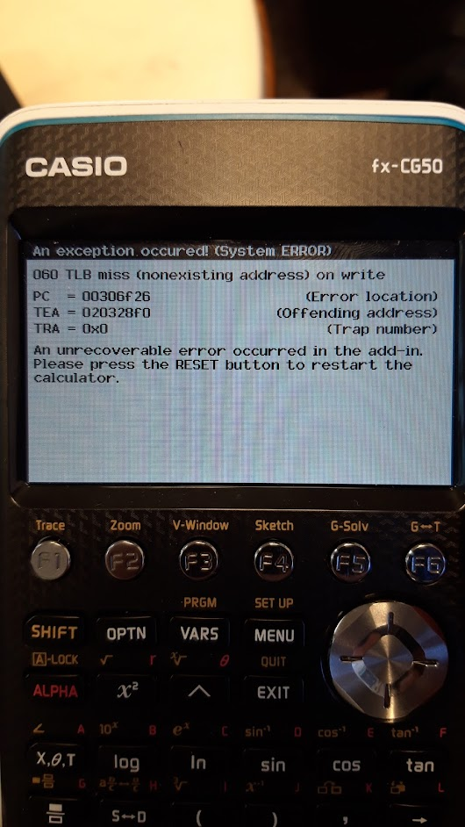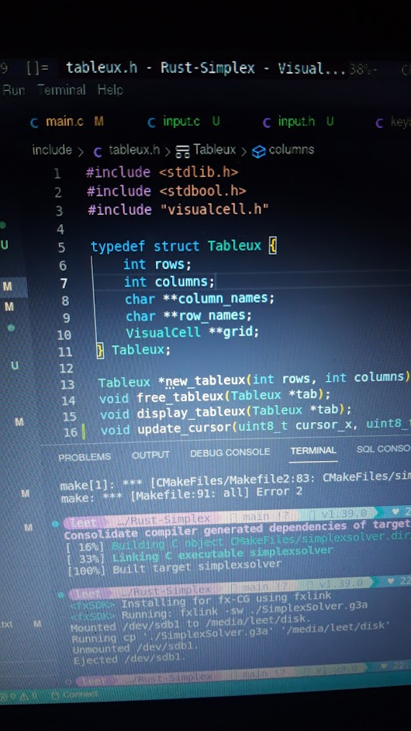

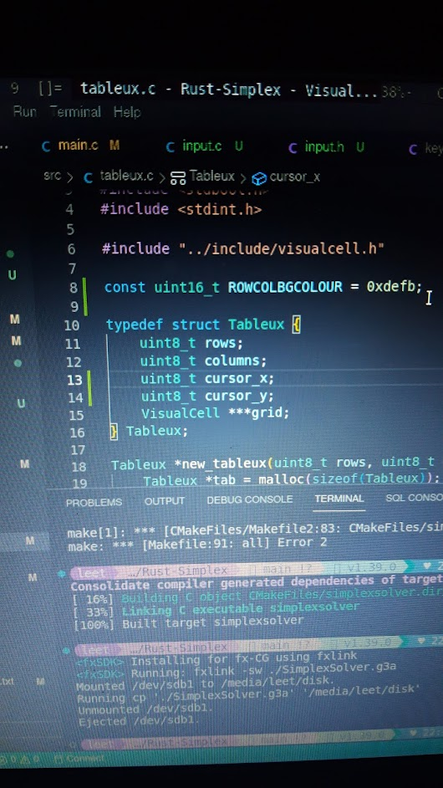

After correcting for this error, I was able to draw a tableux. I hardcoded the text for certain cells, as that will always be their value and it should never change.

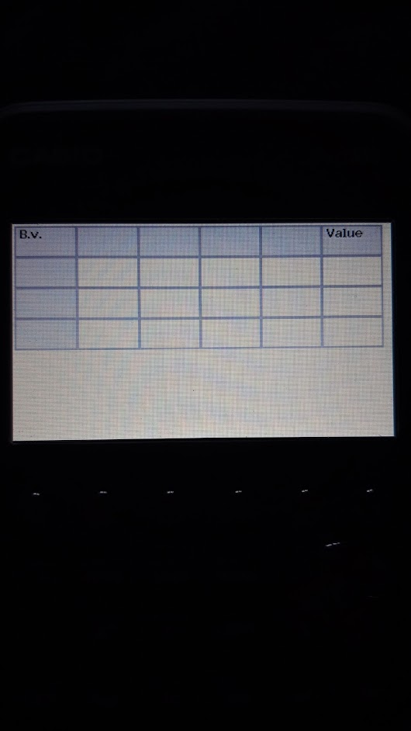

While the tableux does store the location of the cursor, it is not currently drawn. I decided to just highlight the cell that contains the cursor to show it. I was trying to do this with a gray colour, but some confusion with 16bit colours in hexadecimal caused it to come out orange, however I was able to highlight it:

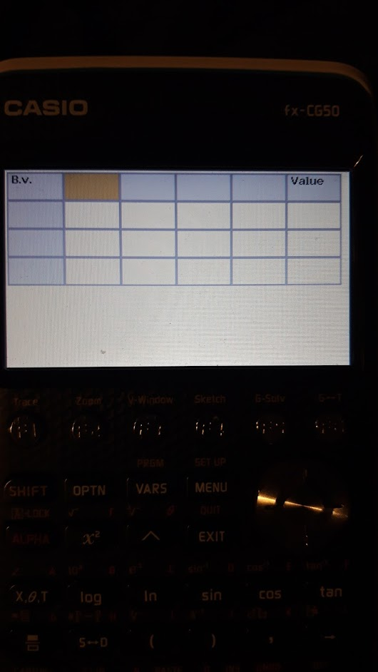

Now that I know that the cursor is correct, I want to make it look better, so I changed it such that the cursor is shown at a thicker border on the cells. As well as this, I went ahead and added code to process key input so that the cursor can move around. In the following image I had been able to move the cursor from the position indicated above to the position shown using the arrow keys on the calculator.

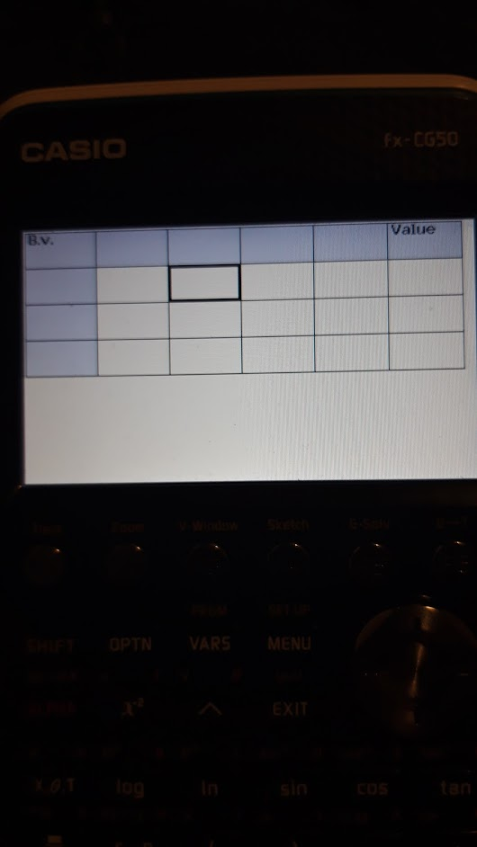

I found that trying to move the cursor past the position shown above, in either direction – right or down – would cause the program to crash. This was confusing, but it turned out to be a mistake in the way I was allocating memory for the tableux. I wasn’t correctly allocating memory for the full grid, and it was only partially allocated. Fixing this, I was able to traverse the entire tableux.

Next, I need to be able to input data into the tableux. I used the EXE key to enter a cell for editing, which would change the `editing` bool of the cell the cursor was over, and would allow me to enter text into the cell. This worked, and I was able to enter text into the cell. I was also able to enter it past the border of the cell, so I found it necessary to place a limit on the number of characters in a cell. It is a sufficiently large limit such that it should not become an issue for any use case the software is intended for.

I also need to make sure that the user can pick any size tableux they need, as I was using a hardcoded size for testing purposes. I used the VisualCell struct again to do this, and process key inputs at this stage so that the left and right arrow keys can be used to switch between the cells, and the up and down arrows to increment and decrement the value.

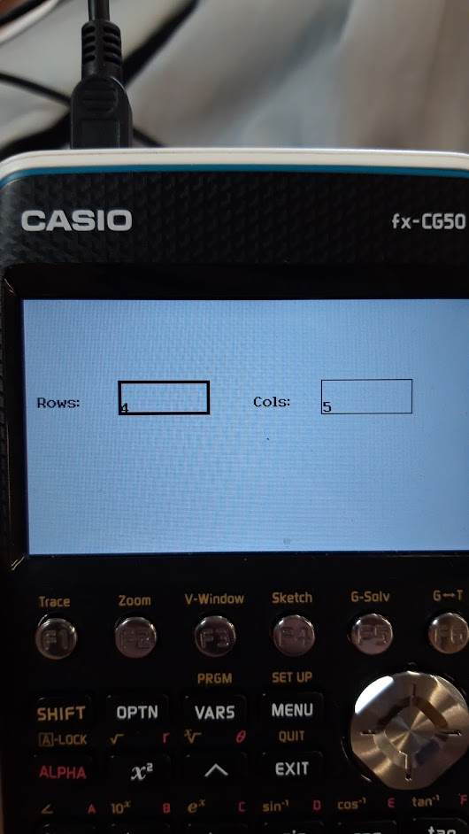

The final step to making this a working product (before refining it) is to solve the tableux once it is filled in. I wrote functions to check that the tableux is filled, and made sure to prevent the user from entering characters into any cells that shouldn’t contain those characters.

The user can presss the F6 key on the calculator to try to move to the next stage. If the checking function returns `true` then the next stage is entered. The user can tell the program to solve the tableux this way.

I implemented some functions to extract the row and column names from the tableux, as well as extracting the data into a Matrix struct. Using these functions I extracted the data, ran simplex on it and re-inserted the result into the tableux to display.

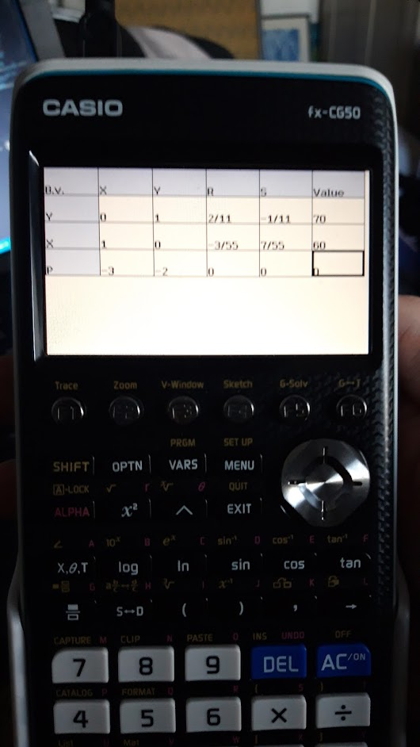

This result is incorrect, but contains elements of the correct answer. This confused me so I decided to run the same test on my computer, commenting out any code that required the calculator – this being the drawing functions for the Tableux and VisualCell. Running this test showed me that the grid, row and column names were all being extracted correctly, and that the simplex solution was correct, but that trying to put the matrix back into the tableux was failing. This was due to a mis-match in indexes: the shape of the matrix is one less in each dimension than the tableux. Original code, and then the fix is shown below:

Tableux *matrix_into_tableux(Matrix *mat, char **row_names, Tableux *tab) {

// Set row titles

for (int i=1; i < mat->rows; i++) {

tab->grid[i][0]->contents = row_names[i-1];

}

// Insert matrix data as strings

char *str = malloc(25 * sizeof(char));

for (int i=0; i < mat->rows; i++) {

for (int j=0; j < mat->columns; j++) {

tab->grid[i][j]->contents = strdup(BigM_str(get(mat, i, j), str));

}

}

return tab;

}

fixed:

Tableux *matrix_into_tableux(Matrix *mat, char **row_names, Tableux *tab) {

// Set row titles

for (int i=1; i < mat->rows; i++) {

tab->grid[i][0]->contents = row_names[i-1];

}

// Insert matrix data as strings

char *str = malloc(25 * sizeof(char));

for (int i=0; i < mat->rows; i++) {

for (int j=0; j < mat->columns; j++) {

tab->grid[i+1][j+1]->contents = strdup(BigM_str(get(mat, i, j), str));

}

}

return tab;

}

I needed to add one to each of the indexes for the `grid`, and this fixed the issue.

With this issue fixed, I tested again and was able to generate a solved tableux succesfully:

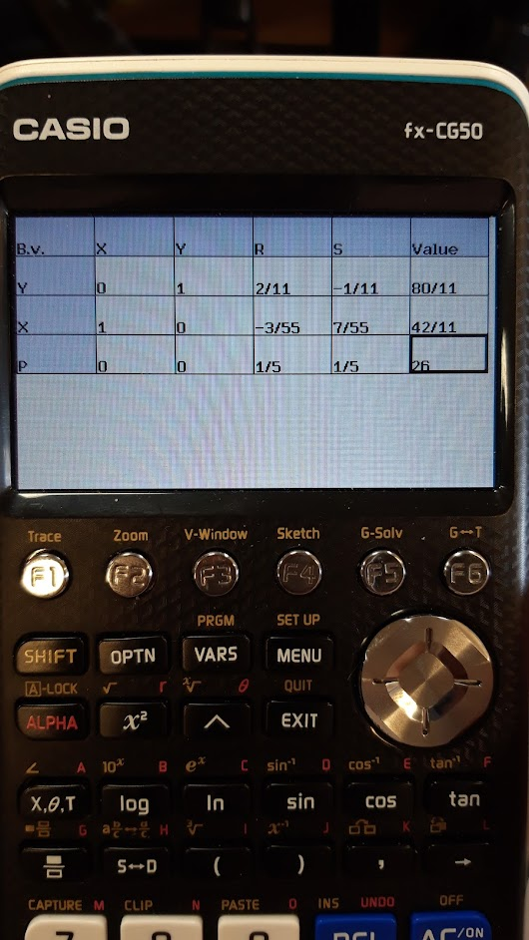

This is now a technically working product. The new code is shown below:

**main.c**

#include <gint/display.h>

#include <gint/keyboard.h>

#include <stdlib.h>

#include <stdio.h>

#include "../include/fraction.h"

#include "../include/bigm.h"

#include "../include/matrix.h"

#include "../include/simplex.h"

#include "../include/tableux.h"

#include "../include/input.h"

#include "../include/stages.h"

Tableux *tableux_construction_stage() {

VisualCell *row_number_cell = new_viscell(80, 70, 80, 30, true, "4");

VisualCell *column_number_cell = new_viscell(260, 70, 80, 30, false, "5");

bool exit = false;

while (!exit) {

dtext(10, 85, 0x0000, "Rows:");

dtext(200, 85, 0x0000, "Cols:");

draw_cell(row_number_cell);

draw_cell(column_number_cell);

dupdate();

key_event_t key = getkey();

exit = process_key_construction_stage(key, row_number_cell, column_number_cell);

}

uint8_t row_num = atoi(row_number_cell->contents);

uint8_t column_num = atoi(column_number_cell->contents);

free_viscell(row_number_cell);

free_viscell(column_number_cell);

Tableux *tab = new_tableux(row_num, column_num);

return tab;

}

int tableux_input_stage(Tableux *tab) {

key_event_t key;

uint8_t cursor_x = 1;

uint8_t cursor_y = 0;

uint8_t stage = 0;

while (true) {

display_tableux(tab);

dupdate();

dclear(0xffff);

key = getkey();

if (key.key == 0x84)

break;

switch (stage) {

case 0:

if (process_key_rowcol_stage(key, &cursor_x, &cursor_y, tab)) {

stage = 1;

}

break;

case 1:

if (process_key_tableux_stage(key, &cursor_x, &cursor_y, tab)) {

stage = 2;

}

break;

// Once `stage` reaches 2, the tableux is ready.

// Move on to the next part of the program.

default:

return 0;

}

update_cursor(cursor_x, cursor_y, tab);

}

return 0;

}

int solve_stage(Tableux *tab) {

BigM **data = extract_grid(tab);

char **row_names = extract_row_names(tab);

char **column_names = extract_column_names(tab);

Matrix *mat = new_matrix_with_data(tab->rows-1, tab->columns-1, data);

*mat = simplex(*mat, row_names, column_names);

tab = matrix_into_tableux(mat, row_names, tab);

return 0;

}

int main() {

dclear(0xffff);

Tableux *tab = tableux_construction_stage();

tableux_input_stage(tab);

solve_stage(tab);

dclear(0xFFFF);

display_tableux(tab);

dupdate();

free_tableux(tab);

while (true) {

getkey();

}

return 0;

}

**tableux.c**

#include <stdlib.h>

#include <stdio.h>

#include <stdbool.h>

#include <stdint.h>

#ifndef FXCG50

#define FXCG50

#endif

#include "../../include/visualcell.h"

#include "../../include/fraction.h"

#include "../../include/bigm.h"

#include "../../include/matrix.h"

const uint16_t ROWCOLBGCOLOUR = 0xdefb;

const uint8_t MAXROWS = 5;

const uint8_t MAXCOLS = 8;

const uint8_t MINROWS = 4;

const uint8_t MINCOLS = 5;

typedef struct Tableux {

uint8_t rows;

uint8_t columns;

uint8_t cursor_x;

uint8_t cursor_y;

VisualCell ***grid;

} Tableux;

Tableux *new_tableux(uint8_t rows, uint8_t columns) {

Tableux *tab = malloc(sizeof(Tableux));

tab->rows = rows;

tab->columns = columns;

// To ensure that we fill the screen.

unsigned int cellwidth = 394 / columns;

unsigned int cellheight = cellwidth / CELL_W_TO_H_RATIO;

// Using calloc to allow us to not set some values.

tab->grid = calloc(rows, sizeof(VisualCell**));

for (int i = 0; i < rows; i++) {

tab->grid[i] = calloc(columns+1, sizeof(VisualCell*));

}

// Assigning each member of the grid its own cell.

for (int i = 0; i < rows; i++) {

for (int j = 0; j < columns; j++) {

tab->grid[i][j] = new_viscell(j*cellwidth, i*cellheight, cellwidth, cellheight, false, "");

}

}

// Setting the first row and column to have a different background colour.

for (int i=0; i < rows; i++) {

tab->grid[i][0]->bgcol = ROWCOLBGCOLOUR;

tab->grid[i][0]->editable = true;

}

for (int i=0; i < columns; i++) {

tab->grid[0][i]->bgcol = ROWCOLBGCOLOUR;

tab->grid[0][i]->editable = true;

}

// Setting the cursor

tab->cursor_x = 1;

tab->cursor_y = 0;

tab->grid[tab->cursor_y][tab->cursor_x]->selected = true;

// Important cell values that wont change

tab->grid[0][0]->contents = "B.v.";

tab->grid[0][columns-1]->contents = "Value";

tab->grid[0][0]->editable = false;

tab->grid[0][columns-1]->editable = false;

return tab;

}

void free_tableux(Tableux *tab) {

if (tab == NULL) {

return;

}

for (int i=0; i < tab->rows; i++) {

for (int j=0; j < tab->columns; j++) {

if (tab->grid[i] != NULL && tab->grid[i][j] != NULL) {

free_viscell(tab->grid[i][j]);

}

}

free(tab->grid[i]);

}

free(tab->grid);

free(tab);

}

void display_tableux(Tableux *tab) {

for (int i=0; i < tab->rows; i++) {

for (int j=0; j < tab->columns; j++) {

draw_cell(tab->grid[i][j]);

}

}

}

void update_cursor(uint8_t cursor_x, uint8_t cursor_y, Tableux *tab) {

tab->grid[tab->cursor_y][tab->cursor_x]->selected = false;

tab->grid[cursor_y][cursor_x]->selected = true;

tab->cursor_x = cursor_x;

tab->cursor_y = cursor_y;

}

char **extract_row_names(Tableux *tab) {

char **row_names = calloc(tab->rows-1, sizeof(char*));

for (int i=1; i < tab->rows-1; i++) {

row_names[i-1] = malloc(25);

strcpy(row_names[i-1], tab->grid[i][0]->contents);

}

return row_names;

}

char **extract_column_names(Tableux *tab) {

char **column_names = calloc(tab->columns-1, sizeof(char*));

for (int i=1; i < tab->columns-1; i++) {

column_names[i-1] = malloc(25);

strcpy(column_names[i-1], tab->grid[0][i]->contents);

}

return column_names;

}

BigM **extract_grid(Tableux *tab) {

BigM **grid = calloc(tab->rows-1, sizeof(BigM*));

for (int i=0; i < tab->rows-1; i++) {

grid[i] = calloc(tab->columns-1, sizeof(BigM));

}

for (int i=0; i < tab->rows-1; i++) {

for (int j=0; j < tab->columns-1; j++) {

grid[i][j] = new_BigM(new_fraction(atoi(tab->grid[i+1][j+1]->contents), 1), new_fraction(0, 1));

}

}

return grid;

}

Tableux *matrix_into_tableux(Matrix *mat, char **row_names, Tableux *tab) {

// Set row titles

for (int i=1; i < mat->rows; i++) {

tab->grid[i][0]->contents = row_names[i-1];

}

// Insert matrix data as strings

char *str = malloc(25 * sizeof(char));

for (int i=0; i < mat->rows; i++) {

for (int j=0; j < mat->columns; j++) {

tab->grid[i+1][j+1]->contents = strdup(BigM_str(get(mat, i, j), str));

}

}

return tab;

}

**input.c**

#include <stdio.h>

#include <stdlib.h>

#include "../../include/tableux.h"

#include "../../include/stages.h"

#ifndef FXCG50

#define FXCG50

#endif

#include <gint/display.h>

#include <gint/keyboard.h>

#include <gint/keycodes.h>

void process_cursor_movement(key_event_t key, uint8_t *cursor_x, uint8_t *cursor_y, Tableux *tab) {

switch (key.key) {

// Up

case KEY_UP:

if (*cursor_y > 0) {

*cursor_y -= 1;

}

return;

break;

// Down

case KEY_DOWN:

if (*cursor_y < tab->rows-1) {

*cursor_y += 1;

}

return;

break;

// Left

case KEY_LEFT:

if (*cursor_x > 0) {

*cursor_x -= 1;

}

return;

break;

// Right

case KEY_RIGHT:

if (*cursor_x < tab->columns-1) {

*cursor_x += 1;

}

return;

break;

default:

break;

}

}

void process_common_keys(key_event_t key, uint8_t *cursor_x, uint8_t *cursor_y, Tableux *tab) {

if (keycode_digit(key.key) > 0) {

char *prev_val = tab->grid[*cursor_y][*cursor_x]->contents;

if (strlen(prev_val) < 20)

sprintf(tab->grid[*cursor_y][*cursor_x]->contents, "%s%d", prev_val, keycode_digit(key.key));

} else if (key.key == KEY_0) {

// Work-around because keycode_digit() for some reason does not include 0.

char *prev_val = tab->grid[*cursor_y][*cursor_x]->contents;

if (strlen(prev_val) < 20)

sprintf(tab->grid[*cursor_y][*cursor_x]->contents, "%s0", prev_val);

} else if (key.key == KEY_DEL) {

const unsigned int length = strlen(tab->grid[*cursor_y][*cursor_x]->contents);

if (length > 0) tab->grid[*cursor_y][*cursor_x]->contents[length-1] = '\0';

} else if (key.key == KEY_MINUS) {

const unsigned int length = strlen(tab->grid[*cursor_y][*cursor_x]->contents);

if (length == 0) tab->grid[*cursor_y][*cursor_x]->contents[0] = '-';

}

}

bool process_key_construction_stage(key_event_t key, VisualCell *row_number_cell, VisualCell *column_number_cell) {

switch (key.key) {

case KEY_UP:

// Increment current cell, if possible

char *end_ptr;

long value;

if (row_number_cell->selected) {

value = strtol(row_number_cell->contents, &end_ptr, 10);

if (value < MAXROWS) {

snprintf(row_number_cell->contents, 3, "%ld", value+1);

}

} else {

value = strtol(column_number_cell->contents, &end_ptr, 10);

if (value < MAXCOLS) {

snprintf(column_number_cell->contents, 3, "%ld", value+1);

}

}

return false;

break;

case KEY_DOWN:

// Decrement current cell, if possible

char *end_ptr_;

long value_;

if (row_number_cell->selected) {

value_ = strtol(row_number_cell->contents, &end_ptr_, 10);

if (value_ > MINROWS) {

snprintf(row_number_cell->contents, 3, "%ld", value_-1);

}

} else {

value_ = strtol(column_number_cell->contents, &end_ptr_, 10);

if (value_ > MINCOLS) {

snprintf(column_number_cell->contents, 3, "%ld", value_-1);

}

}

return false;

break;

case KEY_LEFT:

// Switch cells.

row_number_cell->selected = !row_number_cell->selected;

column_number_cell->selected = !column_number_cell->selected;

return false;

break;

case KEY_RIGHT:

// Switch cells

row_number_cell->selected = !row_number_cell->selected;

column_number_cell->selected = !column_number_cell->selected;

return false;

break;

case KEY_F6:

// User is finished, proceed.

return true;

break;

default:

break;

}

}

bool process_key_rowcol_stage(key_event_t key, uint8_t *cursor_x, uint8_t *cursor_y, Tableux *tab) {

if (key.key == KEY_F6 && check_stage_0(tab)) {

// Change the tableux so that it is ready for

// stage 1.

for (int i=0; i < tab->columns; i++) {

tab->grid[0][i]->editable = false;

tab->grid[0][i]->editing = false;

}

for (int i=0; i < tab->rows; i++) {

tab->grid[i][0]->editable = false;

tab->grid[i][0]->editing = false;

}

for (int i=1; i < tab->rows; i++) {

for (int j=1; j < tab->columns; j++) {

tab->grid[i][j]->editable = true;

}

}

return true;

}

// Code for EXE is common in both branches,

// so process it first to possibly exit early.

if (key.key == KEY_EXE) {

// If the currently selected cell is editable,

// switch the mode of editing.

if (tab->grid[*cursor_y][*cursor_x]->editable) {

tab->grid[*cursor_y][*cursor_x]->editing = !tab->grid[*cursor_y][*cursor_x]->editing;

}

return false;

}

// Processing inputs differently for when we

// are editing a cell than not.

//

// First branch is when not editing a cell.

if (!tab->grid[*cursor_y][*cursor_x]->editing) {

process_cursor_movement(key, cursor_x, cursor_y, tab);

// When editing a cell

} else if (key.alpha) {

char *ch;

// I have removed a large switch statement from the code snippet here

// for conciseness. All it did was interpret the key.key value into a

// character, and place that into `ch`

char *prev_val = tab->grid[*cursor_y][*cursor_x]->contents;

sprintf(tab->grid[*cursor_y][*cursor_x]->contents, "%s%s", prev_val, ch);

} else {

process_common_keys(key, cursor_x, cursor_y, tab);

}

return false;

}

bool process_key_tableux_stage(key_event_t key, uint8_t *cursor_x, uint8_t *cursor_y, Tableux *tab) {

if (key.key == KEY_F6 && check_stage_1(tab)) {

for (int i=1; i < tab->rows; i++) {

for (int j=1; j < tab->columns; j++) {

tab->grid[i][j]->editable = false;

tab->grid[i][j]->editing = false;

}

}

return true;

}

// Code for EXE is common in both branches,

// so process it first to possibly exit early.

if (key.key == KEY_EXE) {

// If the currently selected cell is editable,

// switch the mode of editing.

if (tab->grid[*cursor_y][*cursor_x]->editable) {

tab->grid[*cursor_y][*cursor_x]->editing = !tab->grid[*cursor_y][*cursor_x]->editing;

}

return false;

}

// Processing inputs differently for when we

// are editing a cell than not.

//

// First branch is when not editing a cell.

if (!tab->grid[*cursor_y][*cursor_x]->editing) {

process_cursor_movement(key, cursor_x, cursor_y, tab);

// When editing a cell

} else {

process_common_keys(key, cursor_x, cursor_y, tab);

}

return false;

}

**stages.c**

#include "../../include/tableux.h"

#ifndef FXCG50

#define FXCG50

#endif

#include <gint/display.h>

#include <gint/keyboard.h>

#include <stdint.h>

#include <string.h>

bool check_stage_0(Tableux *tab) {

char *empty = calloc(1, 1);

for (int i=0; i < tab->columns; i++) {

if (tab->grid[0][i]->contents[0] == empty[0]) {

free(empty);

return false;

}

}

for (int i=0; i < tab->rows; i++) {

if (tab->grid[i][0]->contents[0] == empty[0]) {

free(empty);

return false;

}

}

free(empty);

return true;

}

bool check_stage_1(Tableux *tab) {

char *empty = calloc(1, 1);

for (int i=1; i < tab->rows; i++) {

for (int j=1; j < tab->columns; j++) {

if (tab->grid[i][j]->contents[0] == empty[0]) {

free(empty);

return false;

}

}

}

free(empty);

return true;

}

It can be seen in tableux.c::extract_grid that the method for extracting the BigM values from the cells is rudimentary and very limited. It can only process integers, so no fractions may be included (in fact this is entirely prohibited as there is no way to input this currently), and there is no way to process the representation of a BigM value, i.e. 12 – 3M.

I need to prototype a way to process these strings into a whole BigM value, which I can then write properly in C and implement in the app.

My first thought is to look at how people have processed complex numbers, as the format is very similar. People tend to use regular expressions for this task, but C has very limited regular expression support so this would be far more effort than I think it would be worth. I will instead write a function that iterates through the string and collects the relevant data.

This is the prototype I have settled upon:

def string_to_bigm_parts(string: str) -> (str, str):

num_part = ""

m_part = ""

temp = ""

# Iterate through the string, checking each character

for char_index in range(len(string)):

if string[char_index] in ("-", "+"):

# If the character occurs past the start

# of the string, this means we can move to

# the m part of the number

if char_index > 0:

num_part = temp

temp = string[char_index]

else:

temp += string[char_index]

else:

temp += string[char_index]

# If num_part has data, then whatever is in

# `temp` must be the m part

if num_part:

m_part = temp

# Otherwise, whatever is in temp can be moved

# into num_part

else:

num_part = temp

# num_part may contain an M value

# (e.g. if the string is "4M")

# so correct that

if "M" in num_part:

num_part, m_part = "", num_part

return (num_part, m_part)

def string_to_fraction(string: str) -> Fraction:

# Important special cases

if string == "-":

string = "-1"

if string == "+":

string = "1"

if string == "":

string = "1"

# Split the fraction into its components

result = string.split('/')

# This case is when the string actually

# contained a '/'

if len(result) > 1:

return Fraction(int(result[0]), int(result[1]))

# If there was no '/' then it is an integer

# and the denominator is one

return Fraction(int(result[0]), 1)

def string_to_bigm(string: str) -> BigM:

parts = string_to_bigm_parts(string)

# Initial values for each part, as they

# may not get set, which corresponds to

# them being zero

num = Fraction(0, 1)

m_part = Fraction(0, 1)

if parts[0]:

num = string_to_fraction(parts[0])

if parts[1]:

m_part = string_to_fraction(parts[1].replace('M', ''))

return BigM(num, m_part)

This code works for all valid inputs. It also generates output for invalid input, like “--M”, which generates -1-M. I need to make it impossible for the user to generate wrong input, by restricting what they can type. I willl also prototype a way of ensuring the input is valid.